Question5
- Create a testcase for exploratory testing
Ans)
Step-by-Step
- Go to Jira → Project
- Click Create Issue
- Select:
  - Issue Type → Test (Xray)
Fill Details:
- Summary → Explore Login Functionality
- Description:
Explore login with valid, invalid, empty inputs and edge cases
Add Exploratory Notes
- Go to Test Details → Manual Test / Exploratory
- Write:
  - Valid login
  - Invalid login
  - Empty fields
  - Special characters
Execute Test
- Go to Test Execution
- Add your test
- Click Execute
- Perform testing manually
- Add:
  - Observations
  - Defects

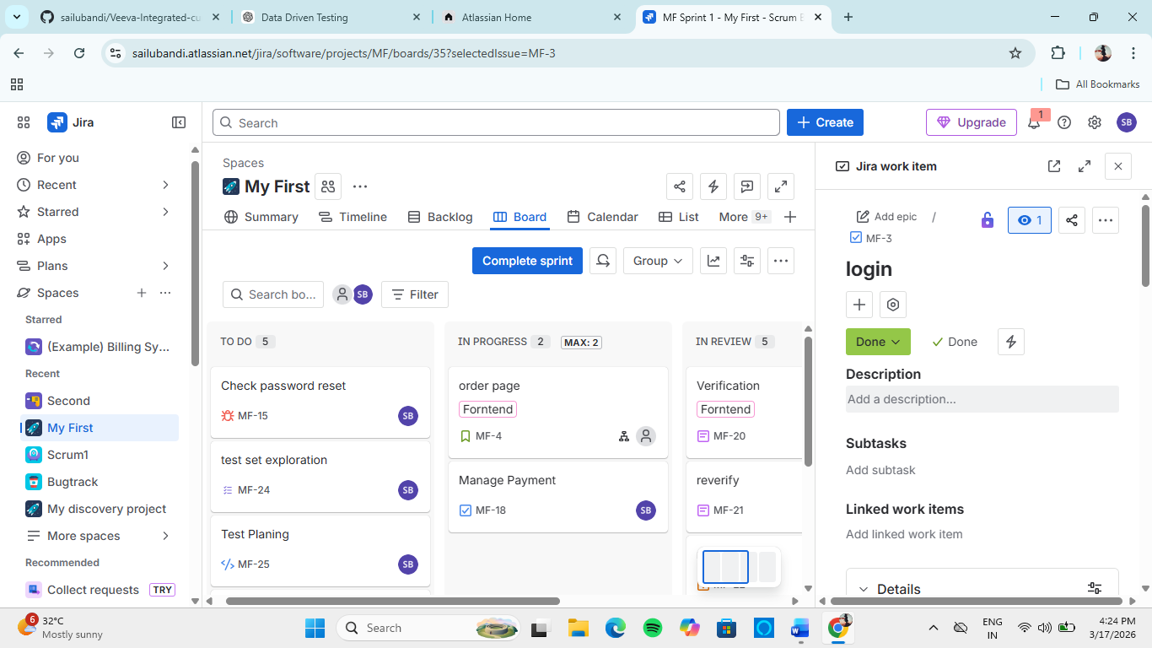

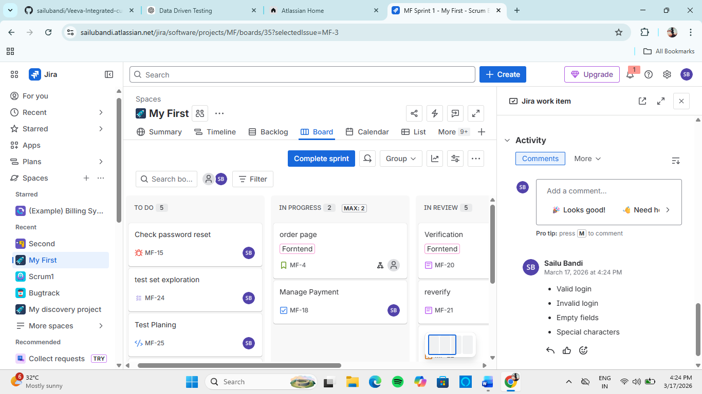

- Track the progress of the specific release or sprint
Sprint Tracking (Jira)
- Go to Project → Board
- Click Active Sprint
You will see:
- To Do
- In Progress
- Done
Burndown Chart
- Click Reports
- Select Burndown Chart
Shows:
- Work remaining vs time
Release Tracking
- Go to Project → Releases
- Select version
Shows:
- Progress %
- Completed vs pending issues
🔹 Test Progress (Xray)
- Go to Xray → Test Execution
- Open execution
You will see:
- Passed
- Failed
- Blocked
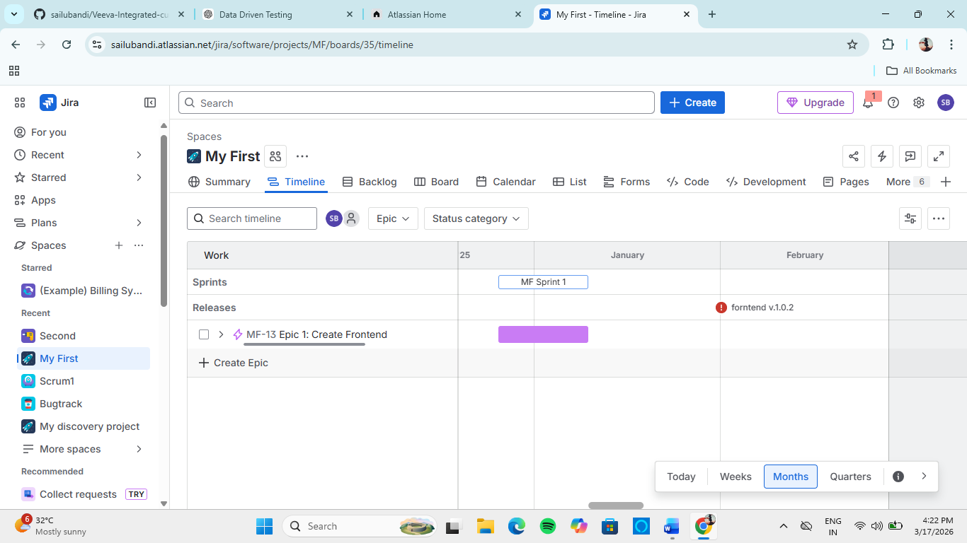
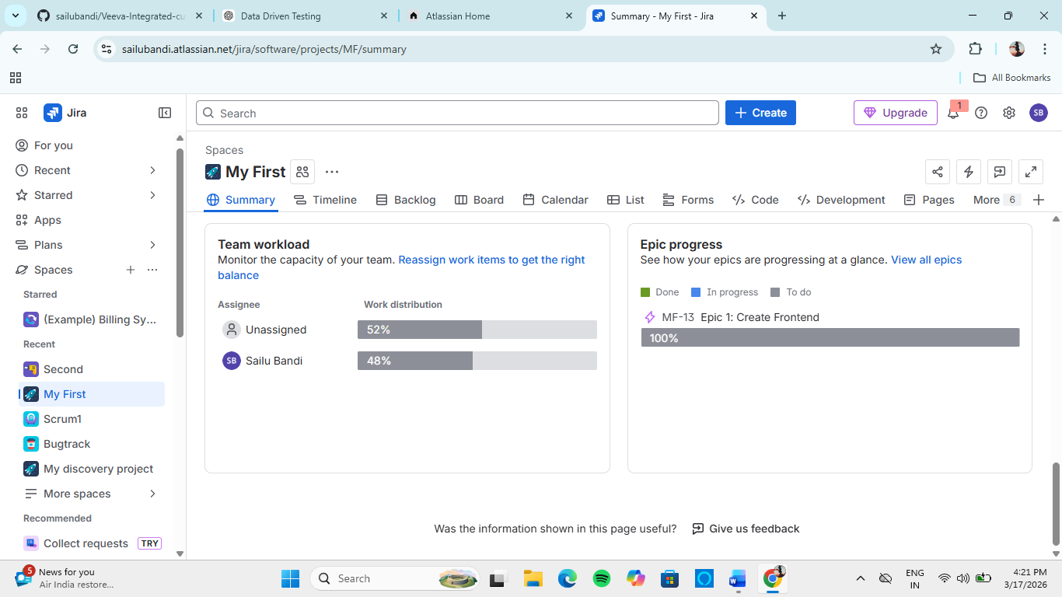
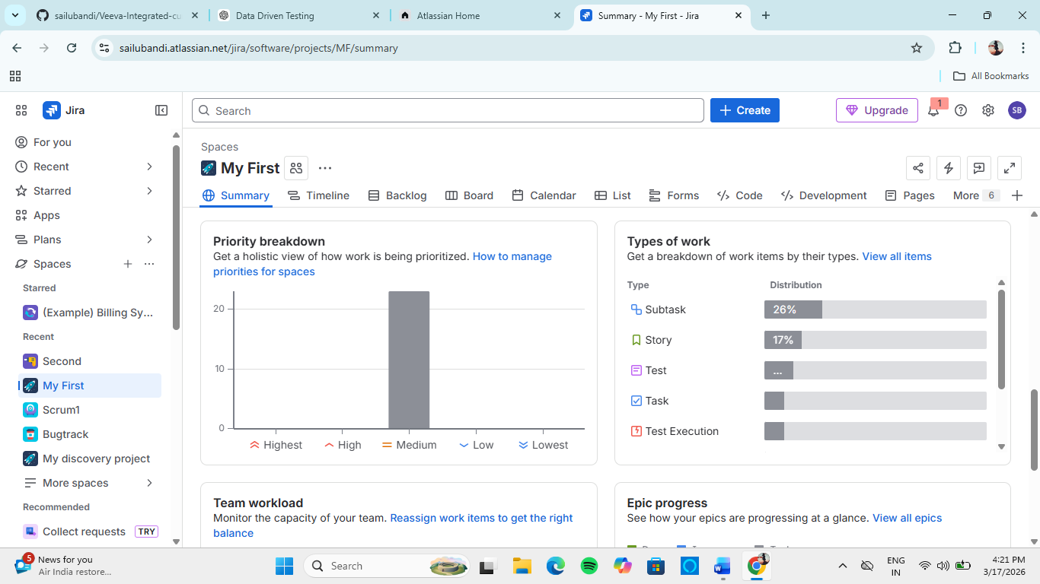

- Demonstrate how to handle re-execution of failed test in xray
Method 1 (Simple)
- Go to Xray → Test Execution
- Open execution
- Filter:
  - Status = FAILED
- Click test
- Click Execute again
- Update result
Method 2 (Best Practice )
- Open Test Execution
- Click Clone
- Remove passed tests
- Keep only failed tests
- Run again
- Save results
Method 3 (Using Test Plan)
- Go to Test Plan
- Select failed tests
- Create new execution
- Run again

